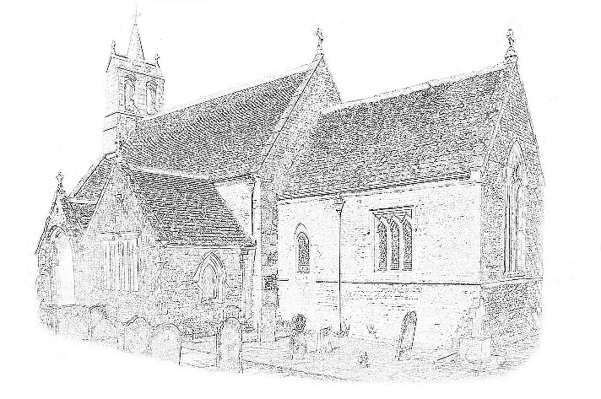 |  |  |  | INVOICE
 |  |  |  |  | To Clerk of SPC
St. Nicholas Church Stretton
 | Payment Terms
Event: Stretton Parish Council Meeting | 29th September 2022

Description | Total
Hiring of Church | £40
Total Due | £40

Please make all cheques payable to Stretton Church General Fund
St. Nicholas Church, Stretton
c/o John Leefe, Hollytree Cottage, Manor Road, Stretton, Rutland, LE15 7QZ

